Hope

&

2019

Ephesians 1:18-19

KidCon Speaker
Brock Boggs

West Texas DYD’s
Nick, Alicia, Nash, Anna

Hope
Ephesians1:18-19
Who: All Students in 1st - 6th grade
When: March 8 -9, 2019
Where: Christian Life Assemblies of God
5917 66th St,
Lubbock, TX 79424
Cost: Students - $40
Leaders - $25
Fun Arts - $5 (per category entered)
KIDCON
This is an event created just for kids! All students in 1st thru 6th grades are invited to join us for this life-changing weekend created to help them experience an incredible time with Jesus and their friends. Students will engage in powerful worship and encounter the presence of Jesus on their level. This is an opportunity for parents to invest in the spiritual formation of their kids. Also, kids can be impacted by God in high energy, dynamic services with others from across West Texas. Registration for KIDCON is available and open until March 8, 2019, at the door.

FUN ARTS
We are excited to offer students the opportunity to participate in FUN ARTS on Saturday after lunch. Students may perform in multiple categories and must pay $5 per category entered. SOME OF THE RULES HAVE CHANGED: PLEASE SEE FUN ARTS RULE BOOK for more information or email wtxnext@gmail.com. Registration for Fun Arts is available and open until February 25, 2019.

HOUSING
Housing will be available at Christian Life for any church outside of the LUBBOCK AREA.
Please bring: Sleeping bags, pillow, change of clothes, toothbrush, etc.

NEED TO BRING
Bible, notebook or journal, pen, dress casual

For more information visit our website: www.wtxnext.com/kidcon or email wtxnext@gmail..com
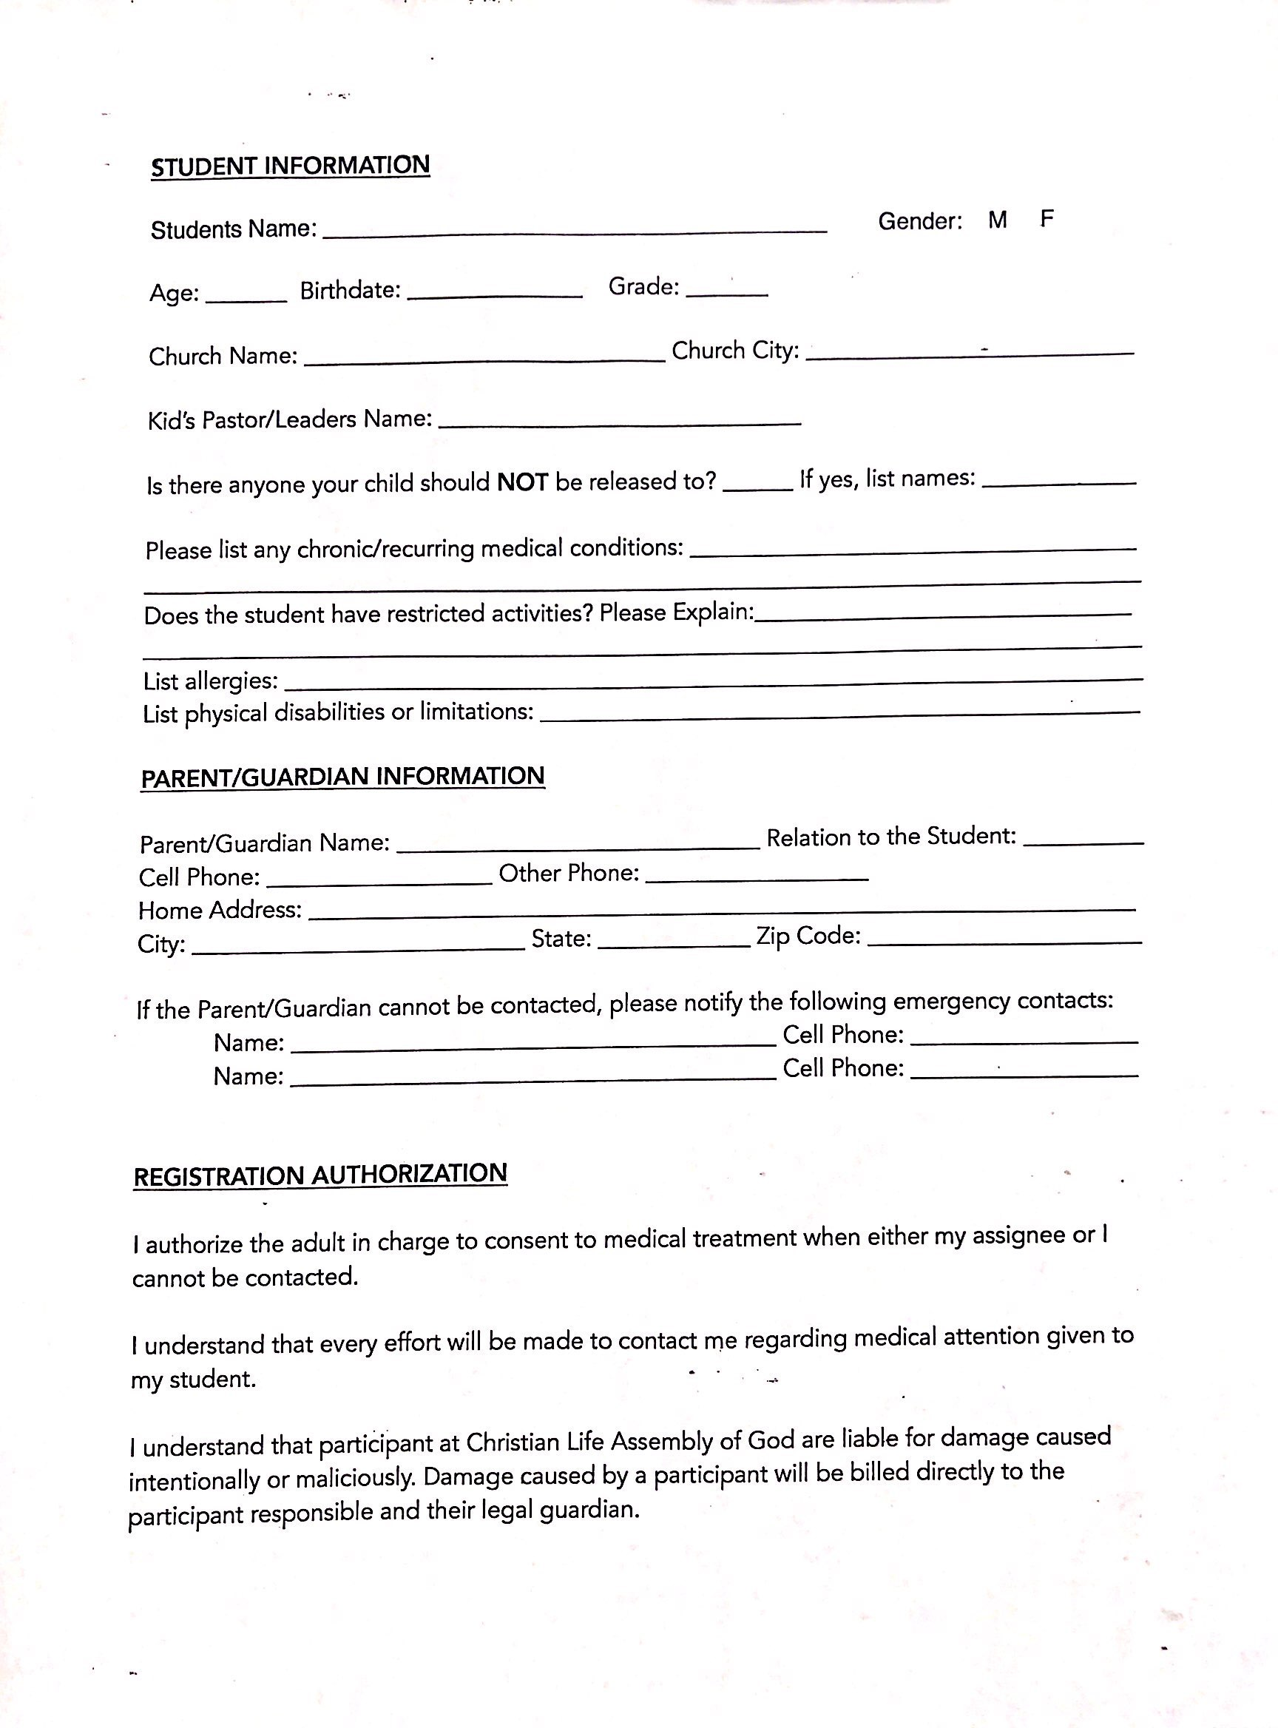

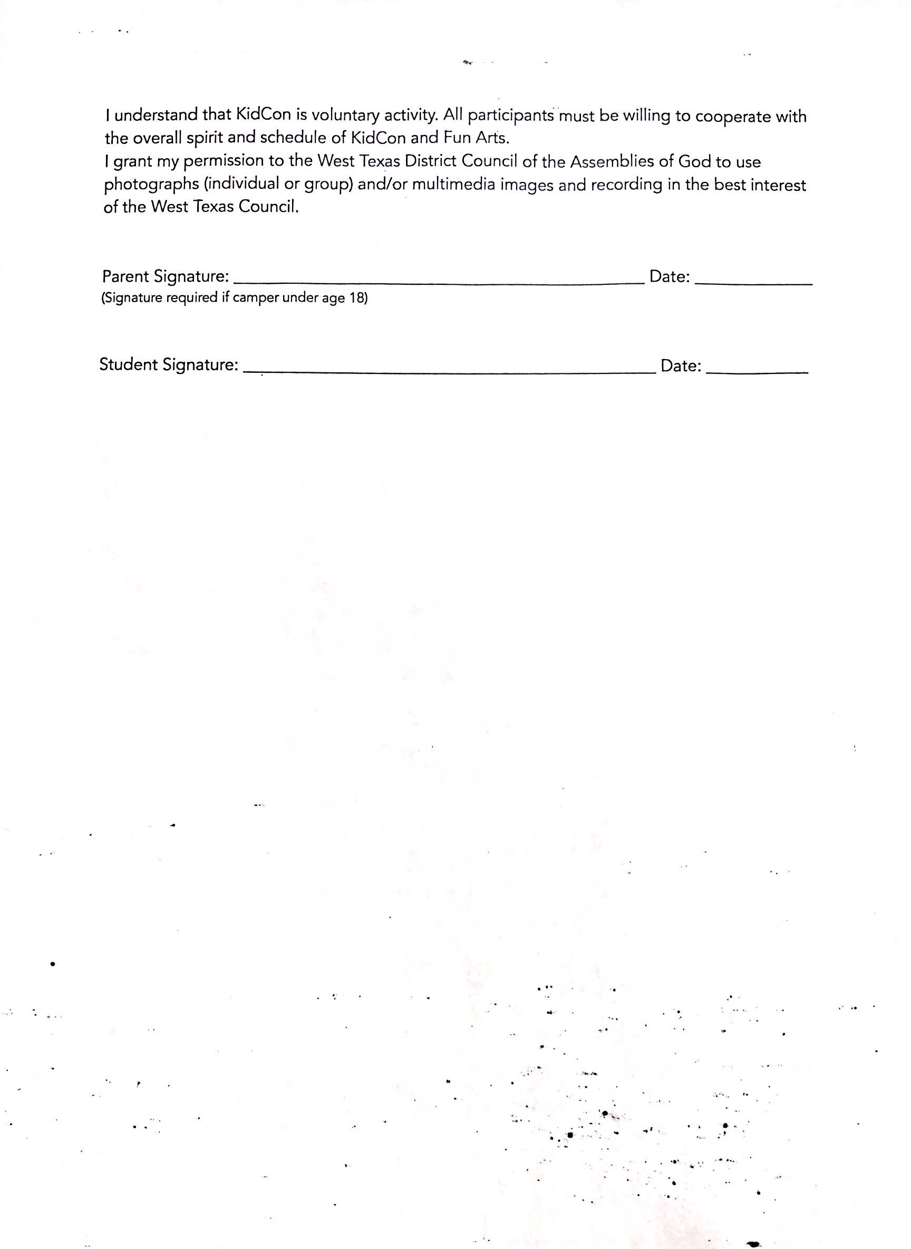
West Texas District FUN ARTS
Group Registration

An entry with 2-10 students is considered a group.

Church Name: ____________________________ | Church City: ______________________________
Kid’s Pastor/Leader Email: __________________________________________________

To ensure that each individual is placed in the correct group(s), please list the members of the groups. Assign each group a different name. Please use a distinctive name for each group. Do not just use your church or category name.

Group Name: ____________________________________________________________
Group Category: _________________________________________________________
Group Members:
1. | 6.
2. | 7.
3. | 8.
4. | 9.
5. | 10.

Groups can only have10 people, except for choirs.
Choirs can continue the list on the back of the form, if necessary.

FUN ARTS INDIVIDUAL REGISTRATION FORM
 | Please circle the categories you are entering. Please indicate Solo or Group on the categories with both options.
Categories
Female Vocal Solo |  | Worship Dance Solo/Group | Craft | Drawing
Male Vocal Solo |  | Step Troupe | Cake Decorating | Painting
Choir |  | Urban Dance Solo/Group | Derby Car | Photography
Christian Band |  | Drama Solo/Group | Poetry | Collage
Vocal Ensemble |  | Human Video Solo | Graphic Design | Plus One
Keyboard Solo |  | Human Video Solo/ Group | Movie Making
Percussion Solo |  | Sign Language Solo/Group | Ministry Display Board
Unconventional Percussion |  | Puppetry Solo/Group
Other Instrument Solo |  | Bible Memorization/JBQ  Solo/Group
Instrumental Ensemble |  | Bible Storytelling Solo/Group
Short Sermon |  | Open

Last Name: __________________________ |  |  | First Name: __________________________ |  |  | Gender:
Parent/Guardian Name: ____________________________________________________ |  |  |  |  |  | M F
Age: ______ | Grade: _____ | Birthdate: _____________________ |  |  | Phone: _____________________
Church Name: ____________________________ |  |  |  | Church City: ______________________________
Kid’s Pastor/Leader Name: ________________________________________________________
Kid’s Pastor/Leader Email: _________________________________________________________
Plus One Participant Name:________________________ Name of Category:_______________________

My signature indicates that I understand and support my child’s involvement in FUN ARTS and will abide by all rules, guidelines, and medical release. I give my permission for hospital or medical center staff to administer any necessary treatment immediately to my child, should he/she be sick or injured during the event. I do not hold West Texas District and its respective officers and staff responsible for any injury as a result of my child’s (or my own) participation in this event.

Parent/Guardian Signature: ___________________________________________ Date: _____________________
Saturday Schedule
8:00-8:30 Breakfast
8:30-9:00 Games
9:10-10:15 Service
9:20 Roundtable
10:15-11:30 Games
11:30-12:20 Lunch
12:30-3:30 Fine Arts
3:30 Depart
Friday Schedule
5:30-7:00 Registration
7:00-8:30 Service
8:30-10:00 Late Night
10:30 Lights Out

GENERAL INFORMATION
Date: Saturday, March 9, 2019
Time: 12:30 - 3:30pm
Location: Christian Life Lubbock, TX
Ages: 1st - 6th grades
Theme: Hope

REGISTRATION
Register by February 25th
Cost: $5 per category
Due to complex scheduling of this event,
late entries will NOT be accepted.

PURPOSE
FUN ARTS is a West Texas District-sponsored event that assists local churches in involving children in ministry.

During the event, children will be given the opportunity to discover and develop their ministry gifts through various performances. The main goal of FUN ARTS is to allow kids to sharpen their talents and gain experience using that as part of their ministry.

FUN ARTS is not designed to be a competition within ministries, but to be a presentation of ministry that is evaluated for purposes of more fully developing the gift God has given to each child.

Although competitive elements are present, a competition is not the sole purpose of FUN ARTS. The evaluation sheets are meant to inspire excellence and offer ideas for improvement in future developments and discovery of skills. The important thing is that kids have the desire to participate, ability to come prepared, and skills developed.

RULES AGREEMENT
FUN ARTS participants and their parent or legal guardian must read and abide by this 2019 FUN ARTS Rulebook.

It is the responsibility of each participant to be familiar with the rules and procedures of this event. No other person may be held responsible for a participant’s lack of information.

By submitting a 2019 registration form and attending or participating in this event, pastors, leaders, parents, and students acknowledge that:
- They understand and agree to abide by the rules of this event.
- They will accept the decisions of the evaluators and coordinators as final.

GENERAL RULES
1. A submission of the registration form indicates that the rules have been read and the participant will abide by all guidelines. Failure to abide by the guidelines may result in disqualification. Participants should always be mindful of their representation of Christ in regard to their behavior. Any participant or attendee showing disrespect to people or property will be dismissed from the event at the director’s discretion.

2. All content used for any entry must be Christian in theme, and all l music must be appropriate for a religious event.

3. Omissions of persons may be allowed at the event; however, additions are not allowed. A substitute in a group entry may be allowed due to emergency; however the substitute must pay full entry fees and fill out a registration form. Substitutions for solo entries are not accepted. Entry fees are non transferable and non refundable.

4. Participants will be expected to be on time for their scheduled performances. If a student is not on time, he/she will be skipped. If there are additional time slots after all performances, the student may be permitted to perform.

5. Appropriate dress is required. Please dress modestly with ministry effectiveness in mind, to glorify Christ. Church or Kids Fun Arts T-shirts are acceptable.

6. The Kids Choir and Instrumental Ensembles are the only categories that allow a conductor or director during the presentation. Standing in the back of the room giving cues or signals is not allowed for all other entries.

7. It is the responsibility of the students, parents, and children’s leaders to be completely legal and ethical in their conduct regarding copyrighted music, scripts, or any other original published or unpublished works.

8. All music must be on a digital device with an output jack such as an MP3 player, iPhone, iPad, iPod, etc. A cord will be provided.

9. Each student in presentation categories should introduce themselves before they perform. For group entries, one person should be designated to give the introduction. See page 7.
10. All materials used must be appropriate for children’s ministry.

AWARDS
The awards given at FUN ARTS are to celebrate each child for their efforts in planning, participating, and performing. Each participant will receive a certificate that is meant to be a reward to inspire excellence and future participation so that developments and discovery of ministry skills can be realized throughout their elementary years.
Please Note: If a student has registered but does not perform, they will not receive a certificate as the certificates are rewards for participating and performing.

EVALUATIONS
Evaluators:
Evaluators will watch the performances and complete the evaluation form for each entry.

Evaluations:
Each child will receive an evaluation sheet from the evaluators. They are not evaluated against each other, but against the guidelines for their category. Rule or time violations will be noted. This evaluation sheet is meant to inspire excellence, and offer ideas for improvement in future developments and discovery of ministry skills.
The evaluation sheets will be grouped together by church during the event. They may be picked up after everyone has performed. All evaluations are final and cannot be contested.

INTRODUCTION GUIDELINES
Each child should be ready to introduce themselves before their solo presentation. Each group should have one person as their spokesperson to introduce their entry. Use the following outline, according to what type of category you have entered, as a guide. Participants should use one line from the examples, NOT ALL THREE.

Introduce yourself:
Hello. My name is _______________________________. I am in ______ grade and I am ____ years old.

Tell specifics about your entry.
Examples:
I am going to sing “Mercy Seat”.
I am going to play “You Raise Me Up.”
I am going to dance to “Shackles”.

Tell about your group.
Examples:
Our group ranges in age from 1st grade to 3rd grade.
We minister on special occasions at our church.
We have been a team for about 3 months.
We are going to perform “God’s Got an Army.”

Drama
Drama Solo/Group
Human Video Solo/Group
Puppet Solo/Group

Communication
Bible Memorization Solo/Group
Bible Storytelling Solo/Group
Sign Language Solo/Group
Short Sermon

Creations
Crafts
Cake Decorating
Derby Car
Sewing

Technical
Graphic Design
Movie Making

Plus One

Visual Arts
Drawing
Painting
Photography
Collage
Sculpturing

Writing
Poetry

Ministry Display Boards

Open Division

PRESENTATION MINISTRIES:
ALL CATEGORIES

Vocal
Female solo
Male solo
Ensemble
Choir
Christian Band

Instrumental
Keyboard Solo
Percussion Solo
Unconventional Percussion
Other Instrument Solo
Instrumental Ensemble

Dance and Movement
Worship Dance Solo/Group
Step Troupe
Urban Dance Solo/Troupe
- Vocals
- Instrumental
- Dance and Movement
- Drama
- Communication
- Open Division

Criteria
1. Presentation Ministries are performed in front of evaluators on the day of the event.
2. No individual or individuals within a group may register for more than one entry in the same category. (Example: You cannot have two vocal solos. You can however, have a solo and be in an ensemble.)
3. All groups consist of 2-10 people. There will be no groups of 11.
4. Sound technicians are provided.
5. Please see each category for time limits and what is provided in the room.
6. Please note that music must be on a digital device.
7. Be prepared to adjust your presentation according to room and stage sizes.

VOCAL SOLO, ENSEMBLE, AND CHOIR
A vocal entry is the art of presenting a vocal song selection that could be presented in church as a ministry.

Criteria
1. Christian music must be used.
2. A music track, youtube video, and/or live accompaniment is permissible. Background vocals and singing over another person’s voice are permitted for solos.
3. Accompanists are not considered part of the entry and are
allowed to use music. A keyboard is all that is provided.
4. There will be a 3 minute time limit for each presentation. There
are 90 seconds for setup and 90 seconds for teardown if needed.
5. The song should be memorized.

CHRISTIAN BAND
A Christian Band is the art of performing Christian music by a group of students whose focus is to perform a song, vocally and instrumentally, with ministry effectiveness in mind.

Criteria
1. Entries in this category must include both music and lyrics.
2. There is a time limit of 5 minutes with 2 1/2 minute setup and
2 1/2 minute tear down. Bands may have assistance in setup and
teardown.
3. All individuals within the band must meet the age requirements.
4 Additional instruments, equipment, and/or additional
percussion accessories are permitted but must be provided by the participants, and only if they can be set up and torn down within the allotted time limit. Please do not bring your own drum set.
5. Students must refrain from any actions that may be deemed offensive or inappropriate (gestures, moves, stage diving, etc.).

What the evaluators are looking for VOCAL SOLO, ENSEMBLE, CHOIR, AND CHRISTIAN BAND:
• Did you choose a song that was not too high or too low for your voice(s)?
• Did you keep with the rhythm of the song?
• Did you project your voice(s)?
• Did you pronounce your words clearly?
• Did you use facial expressions to express emotions?
• Did you look at the audience?
• Did you use friendly smiles?
• Did you use your hands to express emotions?
- Did you present yourself with calmness and a good attitude?

INSTRUMENTAL SOLO/ENSEMBLE
An instrumental solo/ensemble entry is the art of presenting a musical composition using only musical instruments that could be presented to an audience. A keyboard and drum set will be provided.

Criteria
1. Christian music is desirable; however, we will accept other genres as long as it is still a tasteful selection.
2. A music track or live accompaniment is permissible. Only a keyboard is allowed as live accompaniment. The instrument being played by the individual cannot be used on the accompaniment tape. The music track cannot have background vocals.
3. Accompanists are not considered part of the entry and are allowed to use music. (i.e. a pianist may accompany a flute player).
4. Instrumental ensemble will allow any musical instrument combination. However, each instrument must be played by a qualified entrant.
5. There will be a 4 minute time limit for each presentation, with a 90 second setup and 90 second teardown time limit. This time may be used to tune instruments and warm up.
6. Acceptable instruments include: keyboard, woodwinds, brass, traditional strings instruments, percussion instruments and accessories, electric guitar, and bass, if they can be set up and torn down within the alloted 90 seconds.
7. A keyboard and drum set will be provided. Additional instruments must be provided by participants
a. An unconventional entry may use, for example, pipes, sticks, trashcans, as in a “stomp” band.
8. Memorization is optional.

What the evaluators are looking for INSTRUMENTAL SOLO/ENSEMBLE:
• Did you play the correct notes and did you play them clearly?
• Did you keep the exact rhythm?
• Did you play loud and soft at the appropriate times?
• Did you use good posture?
• Did you present yourself with a calm and good attitude on the stage?
- Did you smile at the audience before and after you played?

WORSHIP DANCE SOLO/GROUP & STEP TROUPE, URBAN SOLO, AND URBAN TROUPE
Worship & Step/Urban dance is the art of presenting an interpretation of a pre-recorded song where the dancer(s)’ desire is to express their personal devotion to Jesus Christ through dance as a form of creative evangelism or expressive witness in offering a visual expression of Christian faith or a Gospel theme presentation that could be presented as ministry in a church.

***Ballet: a classical form of dance characterized by formally precise steps and poses.
***Lyrical: a contemporary form of dance, referred to as “modern” that is a fusion between ballet and jazz. Music is interpreted through expressive and dynamic movements.
***Urban Dance: also known as“street”dance or“hip-hop,”influenced by various rhythms and techniques of hip hop. These movements cannot be suggestive or inappropriate.
***Step: a contemporary form of dance characterized by the incorporation of percussive sounds and movements. These movements cannot be suggestive or inappropriate.

Criteria
1. Christian music must be used. It is preferred that the music contain
words, not just music. If it is just music, it must be easily recognizable as an
appropriate worship song.
2. Troupe entries are groups of 2-10.
2. Mouthing lyrics/lip synching is not permitted. In Step and Urban entries, spoken words may be presented but must not be predominant.
3. Appropriate costuming is allowed. Attire and accessories must not create a
visual distraction. Elaborate costuming or costume make up is not allowed.
4. Dancewear must be appropriate and conducive to a worship atmosphere.
(Nothing low cut, backless, tight, see-through, etc.)
5. Suggestive or inappropriate movements, music, or attire is not permitted.
6. Live accompaniment is not permitted.
7. The use of sets is not permitted.
8. There will be a 4 minute time limit for each presentation, which includes
setup and teardown.
9. Dances must demonstrate specific skills, movements, and elements of the
chosen style.

What the evaluators are looking for in WORSHIP DANCE SOLO/GROUP & STEP TROUPE, URBAN SOLO, AND URBAN TROUPE:
• Did you keep good timing with the music, stay focused, and remembered your parts?
• Did you display creativity and originality?
• Did you use appropriate body movement and attire?
- Did you paint a visual picture with your dance?
- Did you ministered effectively?
- Did you present yourself with a calm and good attitude on the stage?
• Did you use facial expressions to communicate emotions?
- Did you smile at the audience at appropriate times?

DRAMA SOLO/GROUP
Drama is the art of telling a culturally relevant story through verbal communication and action.

Criteria
1. Drama entries must creatively and effectively present a biblical value.
2. Drama entries do not have to be original.
3. There is a 5 minute time limit which includes setup and teardown time.
4. No recorded or electronic sound effects are allowed. Background tracks or
live background music is not allowed.
5. All aspects of the drama must take place within the boundaries of the stage. 6. Simple props are allowed.
7. The use of sets is not permitted.
8. Simple costumes are allowed.
Note: All materials used must be appropriate for children’s ministry.

What the evaluators are looking for DRAMA SOLO/GROUP:
- Did you stay focused?
- Were you confident and prepared to minister?
- Did you remember your parts?
- Did you efficiently portray your character(s)?
- Did you convey the meaning of the presentation?
- Did you introduce, develop, and conclude the presentation?
- Did you use facial and body movements to communicate emotions?
- Did you smile at the audience at appropriate times?
- Did you present yourself with a calm and good attitude on the stage?
- Did you effectively minister?

HUMAN VIDEO SOLO/GROUP
Human Video is the art of telling a story through a non-verbal presentation that accompanies a musical track. It will be evaluated on its ability to be used in a ministry setting and whether or not it can be interpreted easily.

Criteria
1. The music track must include lyrics. Voice-overs may be present in the recording but may not completely replace the lyrics.
2. Live accompaniment is not permitted in Human Video presentations.
3. No live vocal communication of any form is permitted from the actors.
4. The technique of “lip sync” must be present in the majority of the presentation.
5. There is a 5 minute time limit which includes setup and teardown time.
6. Entries do not have to be original, but it is encouraged.
7. All aspects of the Human Video must take place within the boundaries of the stage.
8. Chairs are the only allowed prop. Please do not stand on the chairs. Chairs
will be provided.
9. No costumes, masks, or makeup is allowed.
Note: Acrobatic type movements must be kept to a minimal. The safety of the children should be taken into consideration over any overt type of choreography. It is desirable that a part of the student’s body be in contact with the floor the greatest period of time in a human video. Human Videos will not be evaluated for their acrobatic movement, but for their ability to be used in a ministry setting and for the art of “telling a story” that can be immediately understood by the audience.

What the evaluators are looking for HUMAN VIDEO SOLO/GROUP:
• Did you appropriately introduce, develop, and conclude the presentation?
• Did you stay with the music and/or group?
• Were you confident and prepared to minister?
• Did you represent your character(s) well?
• Did you convey the meaning of the song?
• Did you use facial and body movements to communicate emotions?
• Did you present yourself well on stage?
• Did you smile at the audience at appropriate times?
- Did you effectively minister?

PUPPET SOLO/GROUP
Puppetry is the art of presenting a puppet show for the purpose of encouraging Christians in their faith and to share Christ with others.
**Please note that the puppet stage setup is 4'6" long in the front, and the back is 5'10"x18" long. (6' per section)**

Criteria
1. There will be a 7 minute time limit to the presentation which includes setup and teardown time.
2. A puppetry entry is not required to be original, but it is encouraged.
3. Participants do not have to bring their own puppet stage. It is provided.
4. Black lights, if used, must be brought by participants, as well as any necessary extension cords, stands, etc. You must provide your own person to turn lights on and off.
5. Props and signs may be used but must be provided by the participants and must be contained within the boundaries of the puppet stage.
6. Puppets should be hand manipulated (no life-sized puppets outside the stage are permitted).
7. Ventriloquism is not allowed in the puppetry categories.
Note: Puppet presentations for FUN ARTS are usually puppets singing to a music track with additional elements (such as signs/props, etc.) used to enhance the performance.

What the evaluators are looking for PUPPET SOLO/GROUP:
- Did you use props, black lights, sounds, and/or signs well?
- Did you keep the head from going back while opening the mouth?
- Did the puppet make frequent eye contact with the audience?
- Did you enter and exit the stage appropriately?
- Did you move the puppet’s body to express emotion?
- Did you make the mouth open and close with the words?
- Did you keep your puppet above the stage without sinking?
- Did your puppet seem real?
- Did you effectively minister?

BIBLE MEMORIZATION & JBQ SOLO/GROUP
Bible Memorization and JBQ (Junior Bible Quiz) is the art of presenting a memorized passage of scripture.

Criteria
1. For Bible Memorization and JBQ, the Scripture verse(s) or JBQ questions must be typed out in an Arial font and three copies will need to be turned in. Copies cannot be in pencil, pen, or sharpie - computer typed only.
2. The passage must be recited word for word.
3. The passage must be verbally communicated through a recitation that invokes feeling and passion.
4. There is a 7 minute time limit.
5. You may use hand motions.
6. You may not use props or costumes.
7. This can be a group or solo effort. Up to ten people may be in a group. Not
every member has to memorize the entire passage. Different people may be assigned different sections of the passage.

What the evaluators are looking for BIBLE MEMORIZATION & JBQ SOLO/GROUP:
• Did you change your voice from loud to soft at proper times?
• Did you pronounce words clearly and correctly?
• Did you use facial and body movements to communicate emotions?
• Did you make eye contact with the audience?
• Did you convey the meaning of the message?
• Did you present yourself with confidence?
- Were you creative in your presentation?

BIBLE STORYTELLING SOLO/GROUP
Bible storytelling is the art of choosing a Bible story and retelling it in a creative way, so that it would appeal to children.

Criteria
1. Costumes and props are allowed.
2. The entire presentation must be memorized, including any scripture quotations.
3. The content of the message must be scripturally accurate.
4. There will be a 5 minute time limit on the presentation, including setup and
teardown time.
5. This can be a group or solo effort. 2 to 10 people may be in a group.

What the evaluators are looking for BIBLE STORYTELLING SOLO/GROUP:
- Did you adequately introduce, develop, and conclude the presentation?
- Did you change your voice from loud to soft at proper times?
- Did you pronounce words clearly and correctly?
- Did you use facial and body movements to communicate emotions?
- Did you use your props effectively?
- Did your costumes correspond with the theme of your story?
- Did you make eye contact with the audience?
- Did you convey the meaning of the message?
- Did you handle your props well?
- Did you present yourself with confidence?
- Were you creative in your presentation?

SIGN LANGUAGE SOLO/GROUP
Sign Language is the art of interpreting a pre-recorded song using sign language that could be presented as ministry in a church.

Criteria
1. Christian music must be used.
2. Music must contain lyrics, not just music. Lip synching or singing is
not required or suggested.
3. Appropriate costuming is allowed (such as matching shirts). Attire
and accessories must not create a visual distraction.
4. There will be a 4 minute time limit for each presentation.

What the evaluators are looking for SIGN LANGUAGE SOLO/GROUP:
• Did you keep good timing with the music?
• Did you use appropriate body movement/props to interpret the song?
• Was appropriate attire used?
• Did you paint a visual picture with your signs?
• Did you use correct signs?
• Did you remember your parts?
• Did you display creativity and originality?
• Did you stay focused?
• Did you present yourself with a calm and good attitude on the stage?
• Did you use facial expressions to communicate emotions?
• Did you smile at the audience at appropriate times?
- Did you minister effectively?

SHORT SERMON

An entry in Short Sermon is the art of verbally communicating a biblical message that includes Scripture quotations or readings presented by one eligible student.
1. Scripture reference must be cited with all scripture quotations or readings.
2. Short Sermon entries have a time limit of 4 minutes.
3. Presentations must be in harmony with the Statement of Fundamental Truths of the
Assemblies of God. A copy of the Statement of Fundamental Truths is available Online
at www.ag.org under the “Beliefs” tab.
4. Entries must be original material, not just a memorization of someone else’s sermon.
5. Participants are permitted to use illustrations, personal testimonies, statistics, stories,
etc. Sources must be cited. Participants are allowed to use notes.
6. The sermon does not need to be memorized. Participants may only use a Bible, notes, a podium, and hand-held visual aids.
7. The event provides only the podium.
8. All aspects of the sermon must take place within the boundaries of the stage.
9. The wearing of costumes is not permitted.
10. The use of audio or audiovisual devices is not permitted.
11. Neither flammable nor liquid visual aids are permitted.
12. Presentations must be given with due reverence for God and His people and must not be a cynical or satirical portrayal of any form of the ministry.

What the evaluators are looking for SHORT SERMON:
- What was the purpose in the sermon
- Was there a response time in the conclusion, quotes, scriptures and illustrations or a story to captivate the audience,
- Clear understanding of the main points and a final response.
- How was your posture, stage presence, vocal clarity, timing and transitions, body language and understandable concepts.
- Did you come up with an original entry?

OPEN CATEGORY - SOLO/GROUP
Open Category is an opportunity for participants to express their talents in an arena that is not a listed category in FUN ARTS.
Examples include, but are not limited to:
Martial Arts
Gospel Illusion
“How To” demonstration
Juggling
Gymnastics Floor Routine

Criteria
1. All music used in presentations must be Christian.
2. There will be a 5 minute time limit for the presentation, which includes setup
and teardown time.
3. Appropriate costuming is allowed. Attire and accessories must not create a
visual distraction. Elaborate costuming or costume make up is not allowed.
4. All clothing must be appropriate and conducive to a worship atmosphere.
(Nothing low cut, backless, tight, see-through, etc.)
5. A keyboard will be provided. All other needed instruments must be provided
by the participant(s).

What the evaluators are looking for OPEN CATEGORY - SOLO/GROUP:
• Was appropriate attire used?
• Did you display creativity and originality?
• Did you stay focused?
• Did you present yourself with a calm and good attitude on the stage?
• Did you smile at the audience at appropriate times?
- Did you minister effectively?

CREATION MINISTRIES:
- Crafts
- Cake Decorating
- Sewing
- Derby Car
- Drawing
- Painting
- Photography
- Collage
- Sculpting
- Poetry
- Ministry Board Display
- Graphic Design
- Movie Making

Criteria
1. Creation ministries are delivered to the proper location at the beginning of the event and then evaluated without the student present. All work is completed before the event.
2. A computer typed paper in Arial font of any and all details about your entry must be handed in in certain categories.
3. All Creation Presentations need to be picked up at the end of the FUN ARTS.
4. If any creation ministries are not claimed by the end of FUN ARTS, they will be thrown away.
5. Please see individual categories for rules on each division.
6. The name, age, category, and church name and city must be attached to
each entry.
7. Entries are limited by height, weight, and width.

CRAFT/CAKE DECORATING/SEWING:
Criteria
1. The entry must be an original and creative product that has been made by the participant with only a minimal amount of help.
2. The entry must be neatly and creatively displayed.
3. The participant’s name, age, category and church name and city must be
handed in on a computer typed paper in an Arial font.
4. The entry must be brought to the FUN ARTS creation area at the
designated time.
5. The entry must be picked up after the event. FUN ARTS director is not responsible for entries left behind.
6. Craft & sewing participants will be on display only. They will not have to stand in front of evaluators. Each participant must hand in a typed paper in an Arial font of all details about how the entry was made.
7. Cake decorating may only use cakes and/or cupcakes as the base of their
presentation.
8. The cake decorating category will not be judged for tasting; only
decorating.
9. Creations must be able to be presented on a tabletop. The size and
weight of the creation must stay within the limits of a 20 inch space, width, height, and depth.

What the evaluators are looking for CRAFT/CAKE DECORATING/SEWING:
• Did you come up with a creative entry?
• Did you come up with an original entry?
• Did you creatively display your creation?
- Did you put a lot of effort into your work?
- Did you put a lot of detail into your work?
- Did you show uniqueness and originality?
- Did you use your imagination?
- Did you use neatness in your creation?

VISUAL ARTS(DRAWING/PAINTING)/PHOTOGRAPHY/COLLAGE/SCULPTING
Criteria
1. All entries must be the original work of one student and created in the current FUN ARTS year.
2. Entries need only to be mounted on some type of art, matte, or foam board. Framing is not allowed. No type of glass is allowed. The overall size, including mounting, must not exceed 24”x24” and must not be smaller than 4”x 6”.
3. Paintings on stretched canvas are considered mounted already.
4. Photographs may be digital or 35mm.
5. The following needs to be on the Information page (this page must be handed in on a typed paper in an Arial font):
participant’s name, age, church name, church city, category
(drawing, painting, etc.), and how you created your art/photograph/collage/sculpture (acrylic paint/pencils/markers/glue/etc).
6. Collage should convey a Christian message or celebrate God’s creation.
6. The entry must be brought to the FUN ARTS creation area at
the designated time.
7. The entry must be picked up after the event. FUN ARTS director is not
responsible for entries left behind.

What the evaluators are looking for VISUAL ARTS(DRAWING/PAINTING)/PHOTOGRAPHY/COLLAGE/SCULPTING:
• Did you come up with a creative?
• Did you display your work properly?
• Did you have interesting designs, backgrounds, or depth?
• Did you have interesting lines, curves, and/or shapes?
• Did you use color and/or shadows?
• Did you put a lot of effort and details into your work?
• Did you show uniqueness and originality?
- Did you use your imagination to be creative?

POETRY
Poetry: the art of composing a piece of literature written in meter or verse.

Criteria
1. All entries must be the original work of one student and created in the current FUN ARTS year.
4. Poetry may be rhymed or free verse with a maximum of 25 lines.
5. Entries must be neat. Poetry paper must be typed, double
spaced, with at least one-inch margin on all sides. Adults may do the typing.
6. Poetry entries must be on 8.5x11 white paper and three copies must be turned in.
7. A separate title page should include the title, category, author’s name,
age, church name and church city.
8. The entry must be brought to the FUN ARTS creation area at the
designated time and picked up after the event. FUN ARTS director is not responsible for entries left behind.
9. Poetry must have a Christian message.

What the evaluators are looking for POETRY:
- Did you adequately introduce, develop, and conclude your writing?
- Did you use descriptive words, proper grammar and spelling?
• Did you put a lot of effort and details into your work?
• Is your presentation neatly typed?
- Did you use your words to paint a picture in the mind of the reader?
- Did you show uniqueness and originality?

MINISTRY DISPLAY BOARDS
Criteria
1. The display must be on a large tri-fold display board.
2. Entries must be the original work of only the participant and created during
the current FUN ARTS year.
3. The following needs to be on the Information page (this page must be handed in on a typed paper in an Arial font):
participant’s name, age, church name, church city, and category
(drawing, painting, etc.).
4. The entry must be brought to the FUN ARTS creation area at the
designated time.
5. The entry must be picked up after the event. FUN ARTS director is not responsible for entries left behind.
6. The tri-fold board should communicate on of the following:
a. The work of a particular missionary, or the work of a missionary effort in a particular country through word, pictures, or graphics
b. The individual’s talent or skills through word, pictures, or graphics
c. The individual’s ministry work through word, pictures, or graphics

What the evaluators are looking for MINISTRY DISPLAY BOARDS:
• Did you creatively display your creation?
• Did your board reflect the purpose of your project?
• Did you put a lot of effort and details in your work?
• Did you show uniqueness and originality?
• Did you use your imagination to be creative?
• Did you use photos, objects, and graphics in a creative way?
• Is your presentation neat?

GRAPHIC DESIGN
Criteria
1. Graphic design entries must be mounted flat on an art board or foam board.
2. Entries must be the original work of only the participant and created during
the current FUN ARTS year.
3. Graphic design entries include advertisements, posters, and logos.
4. Digital imagery and computer illustrations are appropriate for this category.
5. The highest resolution available should be used.
6. The following needs to be on the Information page (this page must be handed in on a typed paper in an Arial font):
participant’s name, age, church name, church city, and category
(drawing, painting, etc.).
7. The entry must be brought to the FUN ARTS creation area at the
designated time.
8. The entry must be picked up after the event. FUN ARTS director is not responsible for entries left behind.

What the evaluators are looking for GRAPHIC DESIGN:
• Did you display your work effectively?
• Are your talents evident in your piece?
• Did you have interesting designs, backgrounds, or depth?
• Did you use many lines, curves, and/or shapes?
• Did you use color and/or shadows?
• Did you put a lot of effort and details into your work?
• Did you show uniqueness and originality?
• Did you use your imagination to be creative?

MOVIE MAKING
Criteria
1. Movie should contain a combination of visual images and sounds that effectively communicate the purpose of the movie.
2. Entries must be the original work of only the participant and created during the current FUN ARTS year.
3. The following needs to be on the Information page (this page must be handed in on a typed paper in an Arial font):
participant’s name, age, church name, church city, and category
(drawing, painting, etc.).
4. All movies have a time limit of 3 minutes.
5. The creator must meet the participant requirements, but those in the
movie do not have to meet these requirements.
6. The creator is responsible for following all copyright laws.
7. All entries can be in a DVD format or on a digital device, such as an iPad.
The device must be left at the registration table.
8. Entries should convey a Christian based message.
9. The entry must be brought to the FUN ARTS registration table.
10. The entry must be picked up after the event. FUN ARTS director is not responsible for entries left behind.

What the evaluators are looking for MOVIE MAKING:
• Did you adequately introduce, develop, and end your movie?
• Did you use descriptive words?
• Did you use descriptive actions?
• Did you use descriptive pictures?
- Did you put a lot of effort and detail into your work?
• Did you use proper grammar and spelling?
• Did you show uniqueness and originality?
- Did you use your imagination to be creative?

PLUS ONE
The Plus One category was established to assist those students who may be too shy to participate in FUN ARTS on their own, but they may be more likely to participate with an adult or teen helper. By receiving reassurance, assistance, and support from their “Plus One”, a student may participate in FUN ARTS with a little added security.

The Plus One category is open to any category of FUN ARTS.

Criteria
1. Evaluation will be provided only for the participant not for the adult or teen helper.
2. The “Plus One” adult or teen must submit all registration forms and fees, just like a participating student.
3. To accommodate the size and nature of the presentation, a description of the entry must be included on the registration forms.
4. Please note if you will require a room black-out.
5. Props and costumes are permitted. (Costumes must be modest.)
6. A 4 minute time limit will be imposed for each presentation, with a 2-minute maximum each for set-up and tear down.

What the evaluators are looking for PLUS ONE:
• Was appropriate attire used?
• Did you display creativity and originality?
• Did you stay focused?
• Did you present yourself with a calm and good attitude on the stage?
• Did you smile at the audience at appropriate times?
- Did you minister effectively?

